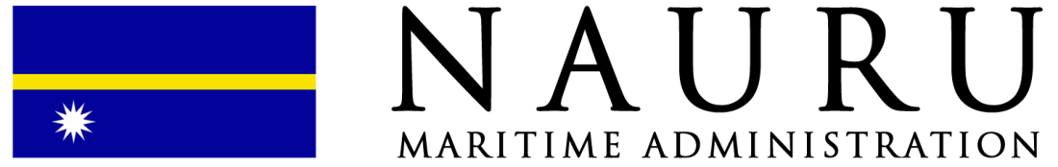

Beneficial Ownership Declaration Form
(For Compliance Purposes)

(FORM NMA-10_BOD.2025.Rev0)
- VESSEL AND REGISTERED OWNER INFORMATION
Vessel Name | Vessel IMO Number |  |  |  | Official Number (if available)
Full Name of Registered Owner | Company IMO Number |  |  |  | Domicile
Registered Owner Address

- DECLARATION OF BENEFICIAL OWNERSHIP
In accordance with the requirements of the Nauru Maritime Administration and relevant international standards on transparency and due diligence, the undersigned hereby declares the following natural person(s) as the ultimate beneficial owner(s) (UBO) of the above vessel.

A beneficial owner means the natural person(s) who ultimately owns or controls the company, whether directly or indirectly, through ownership of shares or voting rights, or by other means.
Full Name |  |  | Nationality | Date of Birth  (dd/mm/yyyy) |  |  | Passport No. | % Ownership
Supporting documents that may be required:
- Copy of passport (photo page) – holder to sign and date.
- If ownership is indirect, attach a corporate ownership structure chart.
- OWNERSHIP STRUCTURE (if applicable)
Company Name |  |  | Domicile | % Shares Held |  |  | Role in Ownership Chain
Supporting documents that may be required:
- Certificate of Incorporation.
- Certificate of Incumbency or Shareholder Register or equivalent.
- Corporate chart showing ownership layers up to natural person(s).
- SANCTIONS AND COMPLIANCE DECLARATION
- None of the beneficial owners, shareholders, directors, or related entities are subject to any sanctions imposed by the UN, EU, US (OFAC), UK (HMT), or others.
- The ownership structure provided is accurate, complete, and current as of the date of signing.
- The Nauru Maritime Administration will be informed immediately of any change in beneficial ownership or control.
- The Nauru Maritime Administration is authorised to conduct independent verification and sanctions screening.
- The Nauru Maritime Administration reserves the right to reject any registration and/or de-register any vessel without compensation if the beneficial ownership information is incomplete, unverifiable, or linked to high-risk or sanctioned persons.
- DECLARATION AND SIGNATURE
Name of Declarant (in full) |  | Position/Title |  |  |  | Date
Company Name |  | Signature
All information collected will be used solely for compliance purposes

